1. COUNT() Function

The COUNT() function is used to count the number of rows in a table that meet a specific condition. It is often used in conjunction with the GROUP BY clause to count rows within each group.

Alias: TotalCount

SQL Statement: 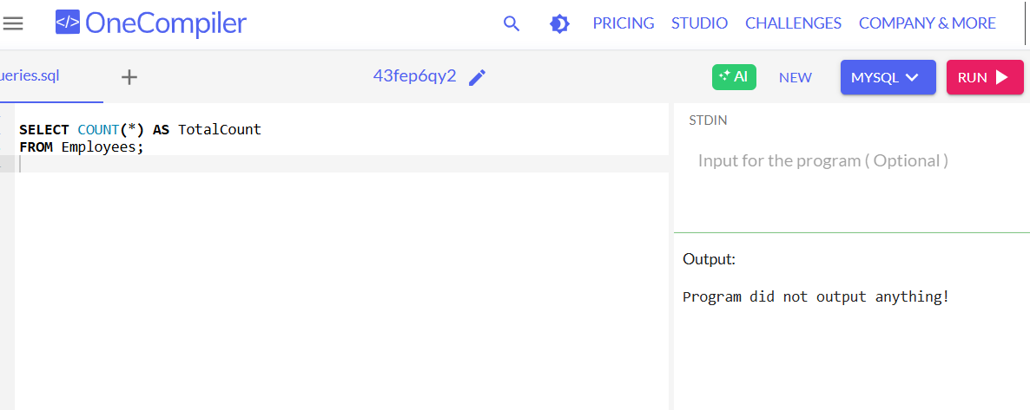

2. AVG() Function

The AVG() function calculates the average value of a numeric column. It is useful for finding the average salary, age, or any other numerical data in a table.

Alias: AverageSalary

3. MAX() Function

The MAX() function returns the maximum value from a specified column. It can be used to find the highest salary, the latest date, or the largest value in a column.

Alias: HighestSalary

